­­

This document describes the procedure to downgrade a 19c database to a 12.x database running in the Linux Oracle Standard Build environment. The areas of the document in a grey box are the output results of each of the commands. The commands to execute are indicated in **BOLD.**

1. **Regardless of what PSU level your 12.1.0.2 was at prior to the upgrade to 19c, you MUST downgrade using a 12.1.0.2 oracle home that is at 2004414 or above. These standard build release levels will contain the required 12.1.0.2 patches to downgrade your 19c database. Ensure 12.1.0.2.200414 or above is installed on your VM.**

1. **(OPTIONAL if DG is in use) Disable log shipping to standby db**

TSTDWNGR> **DISable_log_shipping.sh ${ORACLE_SID}**

1. **(Optional if DG is in use) downgrade standby database on standby server, specify the original release. The script will substitute 200414 if need be.**

TSTDWNGR> **downgrade_standby_db.sh 12.1.0.2.200114 ${ORACLE_SID}**

Start standby DB downgrade of TSTDWNGR on Linux xdopsdbw1d.aetna.com 3.10.0-1062.18.1.el7.x86_64 #1 SMP Wed Feb 12 14:08:31 UTC 2020 at Tue Jul 7 15:04:36 EDT 2020 using /orahome/u01/app/oracle/local/scripts/downgrade_standby_db.sh

Review log file /orahome/u01/app/oracle/local/logs/downgrade_standby_db_TSTDWNGR_20200707_1594148676.out for details

oracle 68709 1 0 15:03 ? 00:00:00 ora_pmon_TSTDWNGR

The downgrade release of oracle must be at least 12.1.0.2.200414. This release contains the patches required for a successful downgrade to 12.1

The database will be downgraded to 12.1.0.2.200414

Oracle DBMS software version 12.1.0.2.200414 is installed, continuing with downgrade

Oracle DBMS software original version 12.1.0.2.200114 is installed, continuing with downgrade

Database exists in ORATAB, continuing with downgrade apply

Start options: read only

Standby database is configured with Active Dataguard, setting startoption to mount for downgrade......

Start option mount has been set.

DBS files for TSTDWNGR have been moved to /orahome/u01/app/oracle/product/12.1.0.2.200414/dbs

Updating srvctl configuration..........

Configuratioin update complete

Setting start option back to READ ONLY.....

Start option has been set.

Switching ORACLE_HOME link

Oracle Home symbolic link has been created as the following:

lrwxrwxrwx 1 oracle dba 52 Jul 7 15:05 /orahome/u01/app/oracle/admin/TSTDWNGR/oracle_home -> /orahome/u01/app/oracle/product/12.1.0.2.200414/db_1

Starting OEM update.........

emcli exists and is executable, updating OEM

The Oracle base remains unchanged with value /orahome/u01/app/oracle

=================================================================================

CUSTOM VARIABLES:

NLS_LANG American_America.UTF8

NLS_DATE_FORMAT DD-MON-YYYY HH24:MI:SS

DB_UNIQUE_NAME tstdwngr_xdopsdbw1d

LISTENER_NAME tstdwngr

BDUMP /orahome/u01/app/oracle/diag/rdbms/tstdwngr_xdopsdbw1d/TSTDWNGR/trace

CDUMP /orahome/u01/app/oracle/diag/rdbms/tstdwngr_xdopsdbw1d/TSTDWNGR/cdump

UDUMP /orahome/u01/app/oracle/diag/rdbms/tstdwngr_xdopsdbw1d/TSTDWNGR/trace

DBS /orahome/u01/app/oracle/product/12.1.0.2.200414/db_1/dbs

LSNRLOG /orahome/u01/app/oracle/diag/tnslsnr/xdopsdbw1d/tstdwngr/trace

TNS_ADMIN /orahome/u01/app/oracle/product/12.1.0.2.200414/db_1/network/admin

=================================================================================

Couldn't find matching DB System

OEM system details could not be retrirved, assume the standby OEM target name is the standby database unique name

Oracle Database Home prior to update: /orahome/u01/app/oracle/product/19.6.0/db_1

Oracle Listener Home prior to update: /orahome/u01/app/oracle/product/19.6.0/db_1

OEM Database Target has been updated with the ORACLE_HOME value of /orahome/u01/app/oracle/product/12.1.0.2.200414/db_1 for database TSTDWNGR_xdopsdbw1d

OEM Listener Target has been updated with the ORACLE_HOME value of /orahome/u01/app/oracle/product/12.1.0.2.200414/db_1 for listener TSTDWNGR_xdopsdbw1d.aetna.com

Oracle Database Home after update: /orahome/u01/app/oracle/product/12.1.0.2.200414/db_1

Oracle Listener Home after update: /orahome/u01/app/oracle/product/12.1.0.2.200414/db_1

Downgrade of TSTDWNGR to 12.1.0.2.200414 complete on Linux xdopsdbw1d.aetna.com 3.10.0-1062.18.1.el7.x86_64 #1 SMP Wed Feb 12 14:08:31 UTC 2020 at Tue Jul 7 15:05:42 EDT 2020 using /orahome/u01/app/oracle/local/scripts/downgrade_standby_db.sh

xdopsdbw1d.aetna.com (oracle) 1960::/orahome/u01/app/oracle/local/scripts

TSTDWNGR>

1. **Backup and delete archive logs to avoid filling the archivelog dump destination during downgrade. You will not be able to back archive logs during downgrade process.**

TSTDWNGR> **backup_archive_logs.sh ${ORACLE_SID}**

Start Archive log backup of TSTDWNGR on Linux xoragdbw2d.aetna.com 3.10.0-1062.18.1.el7.x86_64 #1 SMP Wed Feb 12 14:08:31 UTC 2020 at Fri Jun 19 11:17:52 EDT 2020 using /orahome/u01/app/oracle/local/scripts/backup_archive_logs.sh

Review log file /orahome/u01/app/oracle/local/logs/backup_archive_logs_TSTDWNGR_20200619_1592579872.out for details

The Oracle base remains unchanged with value /orahome/u01/app/oracle

=================================================================================

CUSTOM VARIABLES:

NLS_LANG American_America.UTF8

NLS_DATE_FORMAT DD-MON-YYYY HH24:MI:SS

DB_UNIQUE_NAME tstdwngr_xoragdbw2d

LISTENER_NAME tstdwngr

BDUMP /orahome/u01/app/oracle/diag/rdbms/tstdwngr_xoragdbw2d/TSTDWNGR/trace

CDUMP /orahome/u01/app/oracle/diag/rdbms/tstdwngr_xoragdbw2d/TSTDWNGR/cdump

UDUMP /orahome/u01/app/oracle/diag/rdbms/tstdwngr_xoragdbw2d/TSTDWNGR/trace

DBS /orahome/u01/app/oracle/product/19.6.0/db_1/dbs

LSNRLOG /orahome/u01/app/oracle/diag/tnslsnr/xoragdbw2d/tstdwngr/trace

TNS_ADMIN /orahome/u01/app/oracle/product/19.6.0/db_1/network/admin

=================================================================================

Starting RMAN archive log backup.........

Recovery Manager: Release 19.0.0.0.0 - Production on Fri Jun 19 11:17:59 2020

Version 19.6.0.0.0

Copyright (c) 1982, 2019, Oracle and/or its affiliates. All rights reserved.

.

.

.

1. **Shutdown database and listener**

TSTDWNGR> **srvctl stop database -d ${ORACLE_SID}_<server name>**

TSTDWNGR> **srvctl stop listener -l ${ORACLE_SID}**

1. **Remove database and listener HAS configuration**

TSTDWNGR> **srvctl remove database -d ${ORACLE_SID}_<server name>**

Remove the database TSTDWNGR_xoragdbw2d? (y/[n]) y

TSTDWNGR> **srvctl remove listener -l ${ORACLE_SID}**

1. **Startup downgrade.**

TSTDWNGR> **sqlplus / as sysdba**

SQL*Plus: Release 19.0.0.0.0 - Production on Fri Jun 19 13:01:09 2020

Version 19.6.0.0.0

Copyright (c) 1982, 2019, Oracle. All rights reserved.

Connected to an idle instance.

SQL> **startup downgrade**

ORACLE instance started.

Total System Global Area 2147481656 bytes

Fixed Size 8898616 bytes

Variable Size 704643072 bytes

Database Buffers 1426063360 bytes

Redo Buffers 7876608 bytes

Database mounted.

Database opened.

SQL>

1. **Execute downgrade**

TSTDWNGR> **dbdowngrade**

Downgrading noncdb

SPOOL /orahome/u01/app/oracle/product/19.6.0/db_1/cfgtoollogs/downgrade/catdwgrd.log

xoragdbw2d.aetna.com (oracle) TSTDWNGR::/orahome/u01/app/oracle/diag/rdbms/tstdwngr_xoragdbw2d/TSTDWNGR/trace

TSTDWNGR>

1. Shutdown database

TSTDWNGR> **sqlplus / as sysdba**

SQL*Plus: Release 19.0.0.0.0 - Production on Tue Jul 7 15:55:11 2020

Version 19.6.0.0.0

Copyright (c) 1982, 2019, Oracle. All rights reserved.

Connected to:

Oracle Database 19c Enterprise Edition Release 19.0.0.0.0 - Production

Version 19.6.0.0.0

SQL> **shutdown immediate;**

Database closed.

Database dismounted.

ORACLE instance shut down.

SQL>

1. **Update oratab to point to downgraded version and source your environment**. **The downgrade version must be at least 12.1.0.2.200414.**

TSTDWNGR> . **oraenv**

ORACLE_SID = [TSTDWNGR] ?

The Oracle base remains unchanged with value /orahome/u01/app/oracle

=================================================================================

CUSTOM VARIABLES:

NLS_LANG American_America.UTF8

NLS_DATE_FORMAT DD-MON-YYYY HH24:MI:SS

DB_UNIQUE_NAME tstdwngr_xoragdbw2d

LISTENER_NAME tstdwngr

BDUMP /orahome/u01/app/oracle/diag/rdbms/tstdwngr_xoragdbw2d/TSTDWNGR/trace

CDUMP /orahome/u01/app/oracle/diag/rdbms/tstdwngr_xoragdbw2d/TSTDWNGR/cdump

UDUMP /orahome/u01/app/oracle/diag/rdbms/tstdwngr_xoragdbw2d/TSTDWNGR/trace

DBS /orahome/u01/app/oracle/product/12.1.0.2.200414/db_1/dbs

LSNRLOG /orahome/u01/app/oracle/diag/tnslsnr/xoragdbw2d/tstdwngr/trace

TNS_ADMIN /orahome/u01/app/oracle/product/12.1.0.2.200414/db_1/network/admin

=================================================================================

rcat__TSTDWNGR doesn't exist on NMA_Oracle.

xoragdbw2d.aetna.com (oracle) TSTDWNGR::/orahome/u01/app/oracle/diag/rdbms/tstdwngr_xoragdbw2d/TSTDWNGR/trace

TSTDWNGR>

1. **If the original database version was less than 12.1.0.2.200414, copy the dbs files and tns_admin files from the original ORACLE_HOME to the downgrade ORACLE_HOME. Edit the listener.ora file to update the ORACLE_HOME value.**

TSTDWNGR> **cd $DBS**

TSTDWNGR> **cp $ORACLE_BASE/product/12.1.0.2.200114/db_1/dbs/*TSTDWNGR* .**

TSTDWNGR> **cd $TNS_ADMIN**

TSTDWNGR> **cp $ORACLE_BASE/product/12.1.0.2.200114/db_1/network/admin/*.ora .**

TSTDWNGR> **vi listener.ora**

1. **Startup Upgrade**

TSTDWNGR> **sqlplus / as sysdba**

SQL*Plus: Release 12.1.0.2.0 Production on Fri Jun 19 13:52:06 2020

Copyright (c) 1982, 2014, Oracle. All rights reserved.

Connected to an idle instance.

SQL> startup upgrade

ORACLE instance started.

Total System Global Area 2147483648 bytes

Fixed Size 2926472 bytes

Variable Size 620759160 bytes

Database Buffers 1509949440 bytes

Redo Buffers 13848576 bytes

Database mounted.

Database opened.

SQL>

1. **Reload downgrade release objects**

SQL> **@?/rdbms/admin/catrelod.sql**

1. **If the original release was less than 12.1.0.2.200414, execute datapatch**

TSTDWNGR> **datapatch -verbose**

SQL Patching tool version 12.1.0.2.0 Production on Mon Jun 22 13:47:53 2020

Copyright (c) 2012, 2016, Oracle. All rights reserved.

Log file for this invocation: /orahome/u01/app/oracle/cfgtoollogs/sqlpatch/sqlpatch_23979_2020_06_22_13_47_53/sqlpatch_invocation.log

Connecting to database...OK

Bootstrapping registry and package to current versions...done

Determining current state...done

Current state of SQL patches:

Patch 20348910 (ALTER TYPE REPLACE IN PRVTAQJI.SQL TO BE REPLACE WITH CREATE OR REPLACE TYPE):

Installed in the binary registry only

Patch 21171382 (AUTO DOP COMPUTES A HIGH DOP UNNECESSARILY):

Installed in the binary registry only

Patch 22731026 (XTTS12102: DRG-10602 AFTER MIGRATION FROM RDBMS 11.2.0 TO 12.1.0):

Installed in the binary registry only

Patch 25766182 (MERGE REQUEST ON TOP OF 12.1.0.2.0 FOR BUGS 14666816 22452653):

Installed in the binary registry only

Patch 30502041 (Database PSU 12.1.0.2.200114, Oracle JavaVM Component (JAN2020)):

Installed in the binary registry only

Bundle series PSU:

ID 200114 in the binary registry and not installed in the SQL registry

Adding patches to installation queue and performing prereq checks...

Installation queue:

Nothing to roll back

The following patches will be applied:

30502041 (Database PSU 12.1.0.2.200114, Oracle JavaVM Component (JAN2020))

30340202 (DATABASE PATCH SET UPDATE 12.1.0.2.200114)

20348910 (ALTER TYPE REPLACE IN PRVTAQJI.SQL TO BE REPLACE WITH CREATE OR REPLACE TYPE)

21171382 (AUTO DOP COMPUTES A HIGH DOP UNNECESSARILY)

22731026 (XTTS12102: DRG-10602 AFTER MIGRATION FROM RDBMS 11.2.0 TO 12.1.0)

25766182 (MERGE REQUEST ON TOP OF 12.1.0.2.0 FOR BUGS 14666816 22452653)

Installing patches...

Patch installation complete. Total patches installed: 6

Validating logfiles...

Patch 30502041 apply: SUCCESS

logfile: /orahome/u01/app/oracle/cfgtoollogs/sqlpatch/30502041/23243463/30502041_apply_TSTDWNGR_2020Jun22_13_48_16.log (no errors)

Patch 30340202 apply: SUCCESS

logfile: /orahome/u01/app/oracle/cfgtoollogs/sqlpatch/30340202/23284744/30340202_apply_TSTDWNGR_2020Jun22_13_48_20.log (no errors)

Patch 20348910 apply: SUCCESS

logfile: /orahome/u01/app/oracle/cfgtoollogs/sqlpatch/20348910/19479466/20348910_apply_TSTDWNGR_2020Jun22_13_48_39.log (no errors)

Patch 21171382 apply: SUCCESS

logfile: /orahome/u01/app/oracle/cfgtoollogs/sqlpatch/21171382/19377781/21171382_apply_TSTDWNGR_2020Jun22_13_48_40.log (no errors)

Patch 22731026 apply: SUCCESS

logfile: /orahome/u01/app/oracle/cfgtoollogs/sqlpatch/22731026/22299616/22731026_apply_TSTDWNGR_2020Jun22_13_48_40.log (no errors)

Patch 25766182 apply: SUCCESS

logfile: /orahome/u01/app/oracle/cfgtoollogs/sqlpatch/25766182/21130757/25766182_apply_TSTDWNGR_2020Jun22_13_51_11.log (no errors)

SQL Patching tool complete on Mon Jun 22 13:51:13 2020

xoragdbw2d.aetna.com (oracle) TSTDWNGR::/orahome/u01/app/oracle/local/scripts

TSTDWNGR>

1. **Compile invalid objects**

TSTDWNGR> **sqlplus / as sysdba**

SQL*Plus: Release 12.1.0.2.0 Production on Mon Jun 22 13:59:16 2020

Copyright (c) 1982, 2014, Oracle. All rights reserved.

Connected to:

Oracle Database 12c Enterprise Edition Release 12.1.0.2.0 - 64bit Production

With the Partitioning, Automatic Storage Management, OLAP, Advanced Analytics

and Real Application Testing options

SQL> @?/rdbms/admin/utlrp

TIMESTAMP

--------------------------------------------------------------------------------

COMP_TIMESTAMP UTLRP_BGN 2020-06-22 13:59:28

DOC> The following PL/SQL block invokes UTL_RECOMP to recompile invalid

DOC> objects in the database. Recompilation time is proportional to the

DOC> number of invalid objects in the database, so this command may take

DOC> a long time to execute on a database with a large number of invalid

DOC> objects.

DOC>

DOC> Use the following queries to track recompilation progress:

DOC>

DOC> 1. Query returning the number of invalid objects remaining. This

DOC> number should decrease with time.

DOC> SELECT COUNT(*) FROM obj$ WHERE status IN (4, 5, 6);

DOC>

DOC> 2. Query returning the number of objects compiled so far. This number

DOC> should increase with time.

DOC> SELECT COUNT(*) FROM UTL_RECOMP_COMPILED;

DOC>

DOC> This script automatically chooses serial or parallel recompilation

DOC> based on the number of CPUs available (parameter cpu_count) multiplied

DOC> by the number of threads per CPU (parameter parallel_threads_per_cpu).

DOC> On RAC, this number is added across all RAC nodes.

DOC>

DOC> UTL_RECOMP uses DBMS_SCHEDULER to create jobs for parallel

DOC> recompilation. Jobs are created without instance affinity so that they

DOC> can migrate across RAC nodes. Use the following queries to verify

DOC> whether UTL_RECOMP jobs are being created and run correctly:

DOC>

DOC> 1. Query showing jobs created by UTL_RECOMP

DOC> SELECT job_name FROM dba_scheduler_jobs

DOC> WHERE job_name like 'UTL_RECOMP_SLAVE_%';

DOC>

DOC> 2. Query showing UTL_RECOMP jobs that are running

DOC> SELECT job_name FROM dba_scheduler_running_jobs

DOC> WHERE job_name like 'UTL_RECOMP_SLAVE_%';

DOC>#

PL/SQL procedure successfully completed.

TIMESTAMP

--------------------------------------------------------------------------------

COMP_TIMESTAMP UTLRP_END 2020-06-22 14:00:40

DOC> The following query reports the number of objects that have compiled

DOC> with errors.

DOC>

DOC> If the number is higher than expected, please examine the error

DOC> messages reported with each object (using SHOW ERRORS) to see if they

DOC> point to system misconfiguration or resource constraints that must be

DOC> fixed before attempting to recompile these objects.

DOC>#

OBJECTS WITH ERRORS

-------------------

0

DOC> The following query reports the number of errors caught during

DOC> recompilation. If this number is non-zero, please query the error

DOC> messages in the table UTL_RECOMP_ERRORS to see if any of these errors

DOC> are due to misconfiguration or resource constraints that must be

DOC> fixed before objects can compile successfully.

DOC>#

ERRORS DURING RECOMPILATION

---------------------------

0

Function created.

PL/SQL procedure successfully completed.

Function dropped.

...(14:00:48) Starting validate_apex for APEX_180200

...(14:00:48) grant execute on "SYS"."DBMS_METADATA" to APEX_180200

...(14:00:48) grant execute on "SYS"."KU$_DDL" to APEX_180200

...(14:00:48) grant execute on "SYS"."KU$_DDLS" to APEX_180200

...(14:00:48) Checking missing sys privileges

...(14:00:48) Re-generating APEX_180200.wwv_flow_db_version

... wwv_flow_db_version is up to date

...(14:00:48) Key object existence check

...(14:00:49) Setting DBMS Registry for APEX to valid

...(14:00:49) Exiting validate_apex

PL/SQL procedure successfully completed.

SQL> quit

Disconnected from Oracle Database 12c Enterprise Edition Release 12.1.0.2.0 - 64bit Production

With the Partitioning, Automatic Storage Management, OLAP, Advanced Analytics

and Real Application Testing options

1. **Shutdown database**

TSTDWNGR> **sqlplus / as sysdba**

SQL*Plus: Release 12.1.0.2.0 Production on Mon Jun 22 13:56:11 2020

Copyright (c) 1982, 2014, Oracle. All rights reserved.

Connected to:

Oracle Database 12c Enterprise Edition Release 12.1.0.2.0 - 64bit Production

With the Partitioning, Automatic Storage Management, OLAP, Advanced Analytics

and Real Application Testing options

SQL> shutdown immediate;

Database closed.

Database dismounted.

ORACLE instance shut down.

SQL>

1. **Add database and listener HAS configuration.**

TSTDWNGR> **srvctl add listener -l ${ORACLE_SID} -oraclehome ${ORACLE_HOME} -endpoints "TCP:<PORT>/IPC:${ORACLE_SID}_IPC"**

TSTDWNGR> **srvctl add database -db ${ORACLE_SID}_<server_name> -oraclehome ${ORACLE_HOME} -spfile ${ORACLE_HOME}/dbs/spfile${ORACLE_SID}.ora -instance ${ORACLE_SID} -diskgroup "DATA_01,REDOA_01,REDOB_01"**

1. **Start database and Listener**

TSTDWNGR> **srvctl start database -d ${ORACLE_SID}_<server name>**

**Note: starting the database will start the listener as well.**

1. **Replace ORACLE_HOME symbolic Link**

+ASM> **. oraenv**

ORACLE_SID = [+ASM] ? **${ORACLE_SID}**

The Oracle base remains unchanged with value /orahome/u01/app/oracle

=================================================================================

CUSTOM VARIABLES:

NLS_LANG American_America.UTF8

NLS_DATE_FORMAT DD-MON-YYYY HH24:MI:SS

DB_UNIQUE_NAME tstasm18_xorangw2d

BDUMP /orahome/u01/app/oracle/diag/rdbms/tstasm18_xorangw2d/TSTASM18/trace

CDUMP /orahome/u01/app/oracle/diag/rdbms/tstasm18_xorangw2d/TSTASM18/cdump

UDUMP /orahome/u01/app/oracle/diag/rdbms/tstasm18_xorangw2d/TSTASM18/trace

DBS /orahome/u01/app/oracle/product/18.5.0/db_1/dbs

LSNRLOG /orahome/u01/app/oracle/diag/tnslsnr/xorangw2d/tstasm18/trace

LISTENER_NAME tstasm18

=================================================================================

xorangw2d.aetna.com (oracle) TSTASM18::/orahome/u01/app/oracle/local/scripts

TSTDWNGR> **cd $ORACLE_BASE/admin/${ORACLE_SID}**

TSTDWNGR> **ls -l oracle_home**

lrwxrwxrwx 1 oracle dba 52 Jun 25 10:54 oracle_home -> /orahome/u01/app/oracle/product/12.1.0.2.190416/db_1

xorangw2d.aetna.com (oracle) TSTASM18::/orahome/u01/app/oracle/admin/TSTASM18

TSTDWNGR> **rm oracle_home**

TSTDWNGR> **ln -s $ORACLE_HOME oracle_home**

TSTDWNGR> **ls -l oracle_home**

lrwxrwxrwx 1 oracle dba 43 Jun 26 08:54 oracle_home -> /orahome/u01/app/oracle/product/18.5.0/db_1

**23. Update OEM monitoring configuration for database and listener**

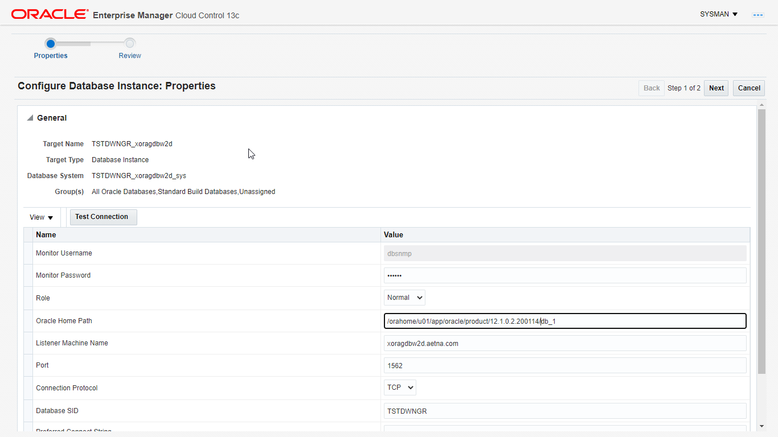

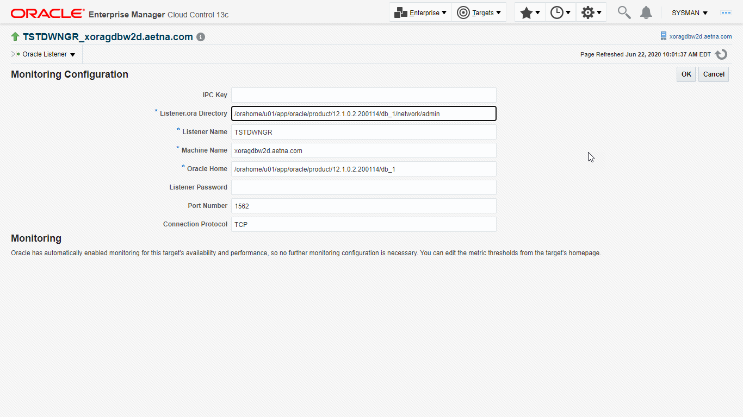

1. **(optional if DG is in use) Enable log shipping**

**TSTDWNGR>ENable_log_shipping.sh ${ORACLE_SID}**

1. **(optional if ADG is in use) Bounce Standby database to place it back in READ ONLY mode. Ensure all logs are applied to the standby before bouncing.**

**TSTDWNGR> srvctl stop database -d ${ORACLE_SID}_<server name>**

**TSTDWNGR> srvctl start database -d ${ORACLE_SID}_<server name>**

**26. (optional if ADG is in use) Bounce OEM agent on standby server.**

**GCAGENT> emctl stop agent**

Oracle Enterprise Manager Cloud Control 13c Release 2

Copyright (c) 1996, 2016 Oracle Corporation. All rights reserved.

Stopping agent ... stopped.

xorangw2d.aetna.com (oracle) GCAGENT::/home/oracle

**GCAGENT> emctl start agent**

Oracle Enterprise Manager Cloud Control 13c Release 2

Copyright (c) 1996, 2016 Oracle Corporation. All rights reserved.

Starting agent .................................... started.

xorangw2d.aetna.com (oracle) GCAGENT::/home/oracle

GCAGENT>